|  |
| --- |
| Computer Programming |
| Course Code: CSC 113 |
| **Assignment 2** |
| Submission Instructions:   * The assignment is to be submitted individually. * Submission deadline is 1 November 2022 |

* For programming questions, include the code and screenshot of output
* Make sure to use this file to submit your solutions.
* **\*Remember to follow best practices, including comments.**

Submission by:

Name: Saad Ahmad Enrollment Number: 01-134222-130

**Problem 1.**

A perfect number is a positive integer that is equal to the sum of its proper divisors. The smallest perfect number is 6, which is the sum of 1, 2, and 3.

Write a program in C++ that takes input from users and checks if a number is perfect or not. It alerts the user if the entered number is not a perfect number.

Create a C++ program that displays the output as given in the video at this link (<https://youtu.be/XuuBOiwiHJk>)

Include complete code and screenshot of the output

**Code:**

#include <iostream>

using namespace std;

int main() {

int num;

int i;

for (;;) {

int sum = 0;

cout << "Enter -1 to exit the program" << endl;

cout << endl;

cout << "Enter a positive number to check if it is a perfect number : ";

cin >> num;

if (num == -1) {

system("color 0F");

break;

}

else {

for (i = 1; i < num; i++) {

if (num % i == 0) {

sum = sum + i;

}

}

if (sum == num) {

cout << "\tNumber is perfect" << endl;

cout << endl;

cout << endl;

system("color 9F");

system("Pause");

system("CLS");

}

else {

cout << "Number is not perfect" << endl;

cout << endl;

cout << endl;

system("color 4F");

system("Pause");

system("CLS");

}

}

}

return 0;

}

**Output:**

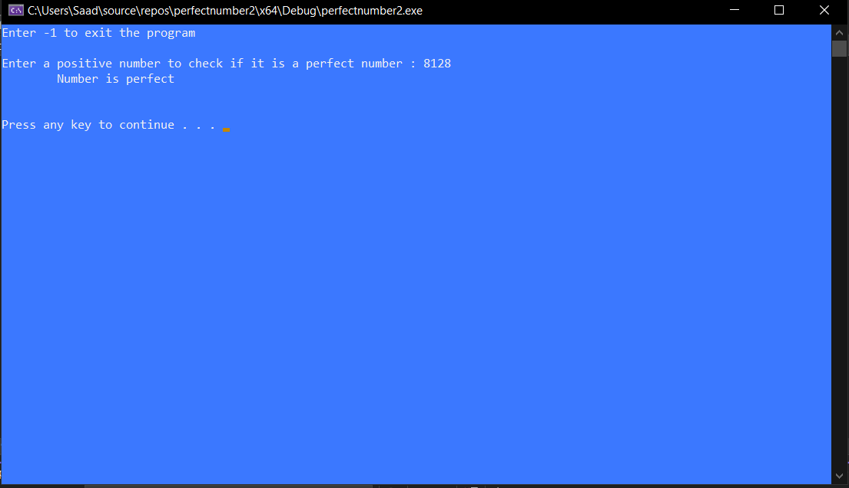

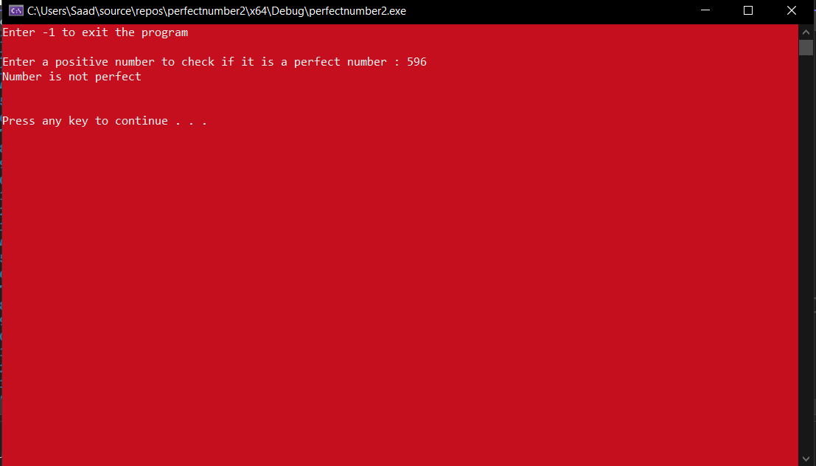

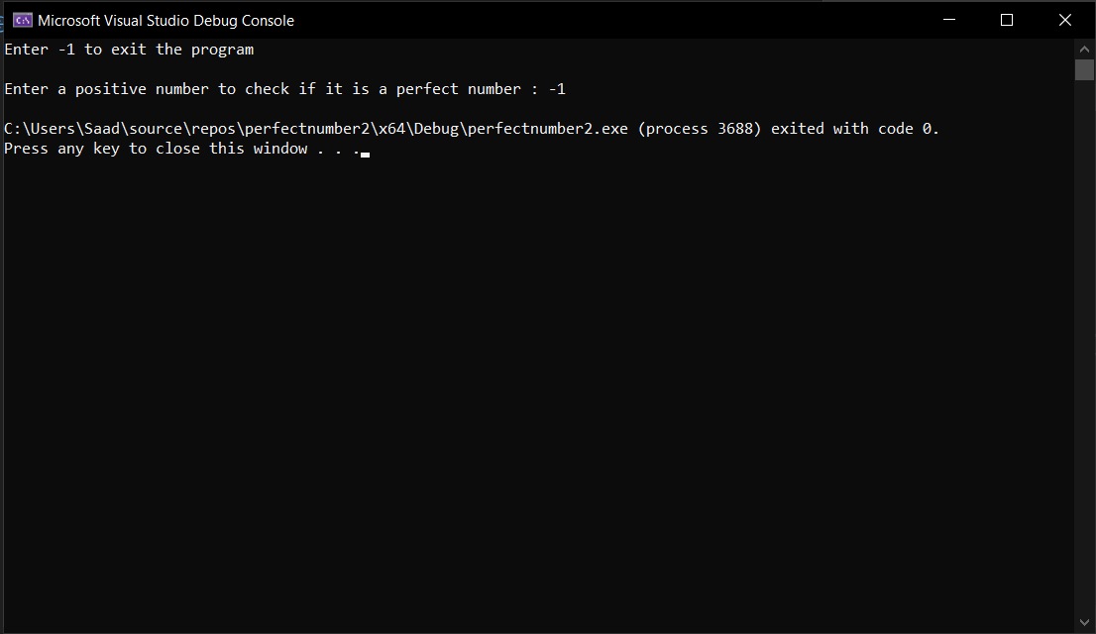

**Problem 2**

An n-digit number is referred as pandigital if it makes use of all the digits 1 to n exactly once.

For example, 213 is a 3-digit pandigital.

Create a C++ program that can identify if a number is pandigital or not.

Include complete code and screenshot of the output

**Code:**

#include <iostream>

#include <string>

using namespace std;

int main() {

string num;

string check = "0123456789";

int a;

int i;

int j;

int k = 0;

int g = 0;

int length;

cout << "Enter a number : ";

cin >> num;

a = num.size();

for (i = 0; i < a; i++) {

length = a;

for (j = 0; j < a; j++) {

if (num[i] == check[length]) {

k++;

}

length--;

}

}

for (i = 0; i < a; i++) {

for (j = i + 1; j < a; j++) {

if (num[i] == num[j]) {

g++;

}

}

}

if (g > 0) {

cout << "The number is not pandigital";

}

else if (a == k) {

cout << "This number is pandigital";

}

else {

cout << "This number is not pandigital";

}

return 0;

}

Output:

